**CS5720**

**Neural Networks & Deep Learning - ICP-3**

**Name: Sai Krishna Reddy Chevutukur**

**#700: 700743830**

**Username: SXC38300**

**Github Link**: <https://github.com/csk17/Neural-Networks-DL-Assignment-3>

**1. Create a class Employee and then do the following**

* Create a data member to count the number of Employees
* Create a constructor to initialize name, family, salary, department
* Create a function to average salary
* Create a Fulltime Employee class and it should inherit the properties of Employee class
* Create the instances of Fulltime Employee class and Employee class and call their member functions.

**Solution:**

* The data member is created to count the number of Employees.
* The constructor is created to initialize name, family, salary, department as “__init__”.
* The function is created to average the salary as “average_salary”.
* Fulltime Employee class is created as it’s inherited the properties of Employee class.
* The instances of Fulltime Employee class and Employee class were created and called their member functions.

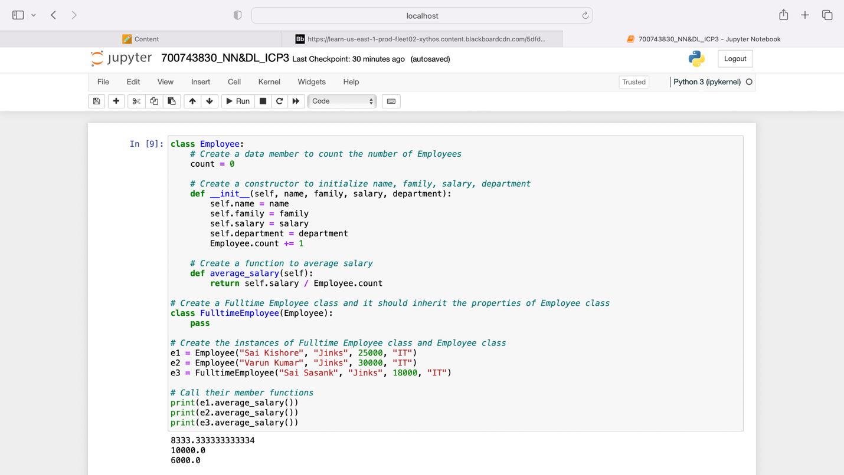

**2. Numpy**

* Using NumPy create random vector of size 20 having only float in the range 1-20. Then reshape the array to 4 by 5  
  Then replace the max in each row by 0 (axis=1)

**Solution:**

* Using “import numpy as np” random vector of size 20 having only float in the given range was created and reshaped the array to 4 by 5 .

